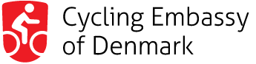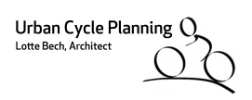

THE BIKEABLE CITY MASTERCLASS – AUGUST 2021

Application Form

Bikeable City Masterclass in Copenhagen August 23-27, 2021
By Urban Cycle Planning and Cycling Embassy of Denmark

Full name:
Occupation:
Mobile no.:
Whatsapp no:
E-mail address:

Company/Agency name:
Company/Agency address:
Company/Agency Org.no/Vat.no:
Billing address:

Send the completed application form to the course organizer, Lotte Bech, Urban Cycle Planning:
lotte@lotte-bech.dk

You will subsequently receive a confirmation of your pre-registration with information on the Danish entry recommendations. You will also receive an invoice containing information about payment with international bank transfer. Final reservation is made at the time of payment.

June 20, 2021: Final deadline for application and payment of course fee, 1.900 € per person.

The course fee includes expert guidance, course material, and expenses for excursion, bike rental, lunch and coffee breaks. Travel and accommodation expenses are not included.

You will receive recommendation on where to stay in Copenhagen (hotel with group reduction and others). We can offer a limited number of private accommodations with members of the Danish Cyclists Federation.

July 1, 2021: Confirmation of the masterclass at the latest on this date. We suggest you arrange flights and hotel after the confirmation.

The masterclass will be confirmed with minimum 18 participants. If it is cancelled due to lack of participants, you will get a full refund of your payment excl. any bank fee.

Please state your ability to participate in the daily guided bike tours. ________________________________

Date/signature __________________________________________________________________________

